Leadership and Six Sigma have foundations in the same tools. Six Sigma is typically considered a rigid and metrics driven approach to management, but nothing could be further from the truth. This methodology is a leadership tool and it is the very foundation of a successful organization. Six Sigma at its essence is an organizational development tool. Think about it, when your staff has the information to improve they become more innovative, more effective and much happier. The key to creating an effective organization lies in DMAIC. DMAIC is the very foundation of Six Sigma and it creates the kind of culture within an organization that breeds success.

What is DMAIC?
DMAIC is not a new term and you’ve probably heard it thrown around in a very technical fashion. The beauty of the term, however lies in its simplicity. DMAIC is a foundational tool and with it organizations develop habits that turn them into world-class competitors. DMAIC is the acronym for Define, Measure, Analyze, Improve and Control. It forces your organization to ask tough but necessary questions about the way they do what they do. When looking inward at your organization, try to ask these questions before you make any changes.
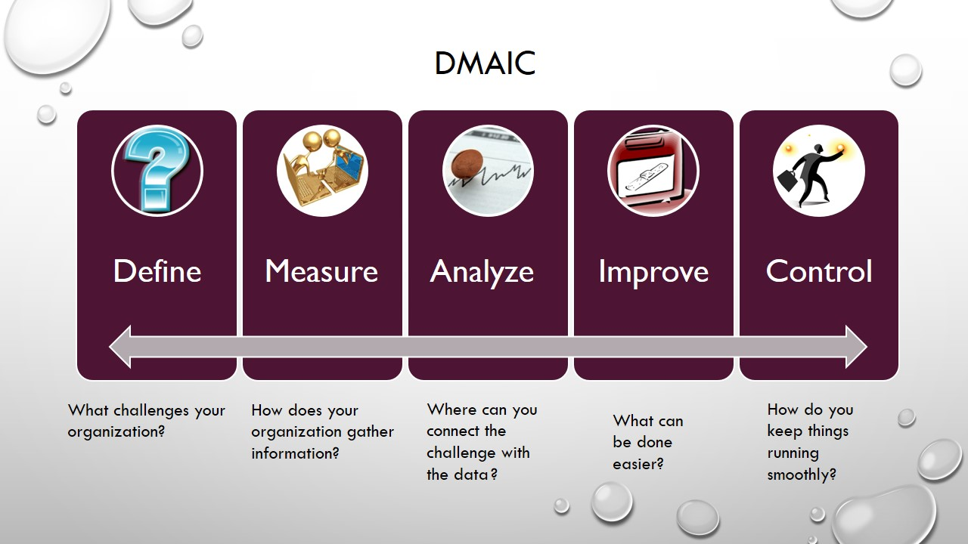

What’s the Business Case?
In every organization there is the desire to put out the best quality of product or service in the market, no one wants to be known as the company who isn’t worth the money. This is where Six Sigma really shows its teeth. It isn’t about measuring widgets, it’s about measuring your worth as an organization. Think of it as physical conditioning, if you don’t put in the work you won’t see the results. Six Sigma teaches you to fine tune the filter and recognize the burning platform issues. On any given day leaders deal with numerous issues and challenges, Six Sigma gives leadership the tools to recognize the gold nuggets of information within the barrels of silver.
While Six Sigma does measure tasks, what that data is telling you is how and why something is happening in your organization. Six Sigma technically speaking measures the amount of variation in your business processes, but those processes are not limited to widgets production. The variation could be in how different receptionists handle phone calls, how different project managers submit invoices and how timesheets are entered. All of these areas play a huge part in your bottom line and all of these areas show how little things become big things when there is not clear instruction on who does what and what goes where. At the end of the day, this little things have a big impact on how much business you can do and how much you can save.
There are 6 Sigma levels within efficient companies and each level carries a very specific definition.
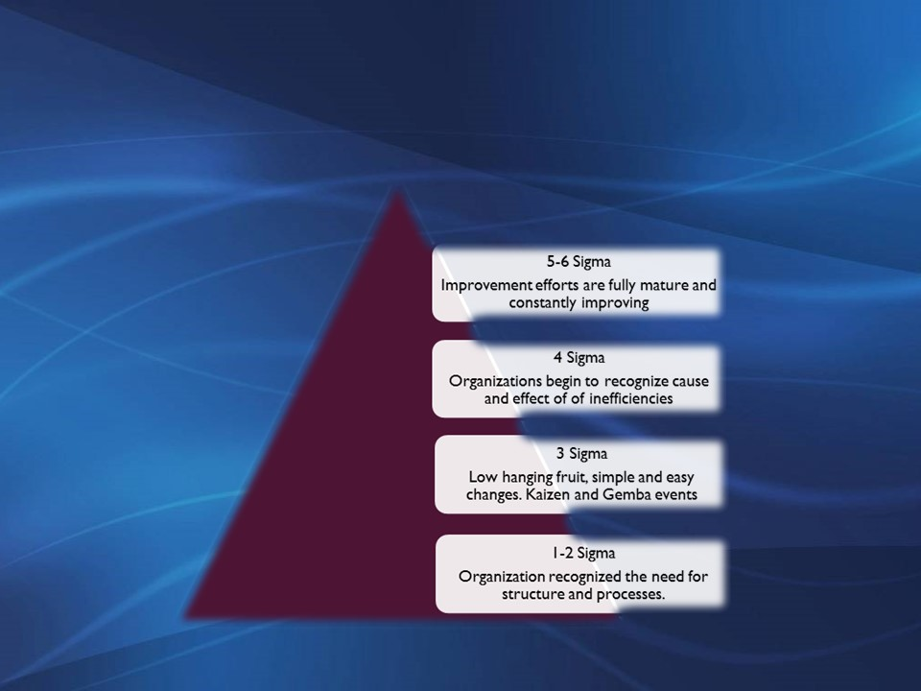
According to the Journal for Quality and Participation, Strategy and Planning Analysis the average company operates at a 4 Sigma level feeling a loss of between 20-40% in sales due to poor quality. Telefonica de espana saved $40m in 10 months using lean principles and methods. That poor quality can be attributed to anything and leadership is often tasked with identifying and remedying that cost, without any direction on how to do just that. Six Sigma shows you how to achieve those savings and how to create a saleable system to repeat that success.
Six Sigma brings order to chaos in business by providing a roadmap that empowers your employees with the capability and knowledge to make more informed decisions, create an efficient way to do their job and help solve business problems at an organizational level.
Our Lean by the Day© system is how we help our clients to create world-class organizations

What is Lean by the Day©?
This our blue print for the success of your project, department or whole organization. There’s what you’ve been doing and then there’s the lean way. What we do is work with you to create a lean system that fits your personality and your company. Here’s how it starts…
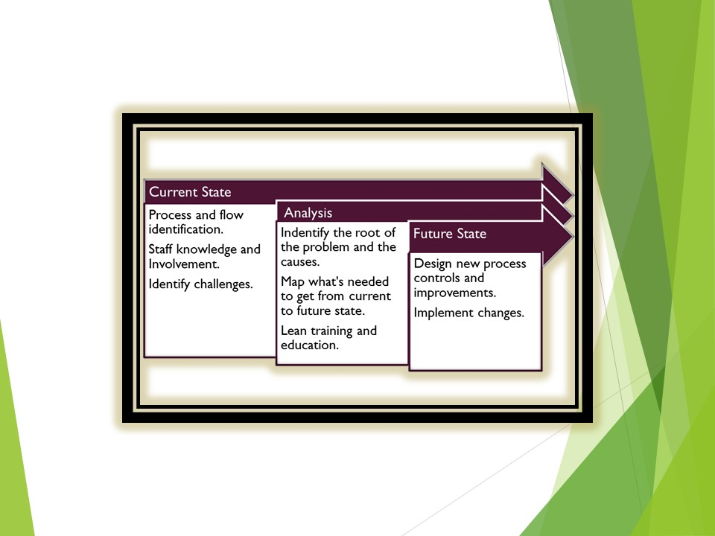
Here’s are the effects of lean that some of the most recognizable companies in the United States are enjoying:
- Dr. Pepper reduced its back office expense by $9m and reduced warehouse and transport costs by $30m in 2 yrs.

- Motorola reduced in-process defects saving $11B.

- Texas Instruments reduced costs by $600m.

- Dow Chemical reduced capital expenditure costs by $2.45m

- DuPont reduced expenses by $25m.
Let’s take a look at how one of our European clients used the lean methods taught to them and put it to work on their production floor.

Oil & Energy Company

The Problem

Significant delays in manufacturing and dispatch goods meant this Oil and Energy Company was experiencing high staff turnover, decreased customer satisfaction and increased spending.

The Solution
The Contract Services division was responsible for the intake, processing, development and dispatch of bespoke manufactured goods for clients. SPC analyzed the current processes and issues defined by the key staff members. These processes were then mapped and SPC used the company's KPI's to determine where the challenges were originating.
This identified that because the engineers and manufacturing staff were not consulted during the sales process, the target dates set for delivery were unrealistic therefore causing the problems.

The Process
SPC developed a process giving the administrative staff 24 hours to acknowledge customer inquiries and 24 hours to respond. This gave 48 hours to determine the most effective course of action for a customer complaint or request. Once the request was received it was forwarded to the Chief Engineer who would review it and determine whether an engineer would need to conduct an onsite repair.

The Result
By reviewing the requests and predetermining the necessity of a site visit, the new process saved the company $25K per month. The senior administrative staff saw their workload reduce by 19.2% and created more involvement, responsibility and a significant reduction in overtime.

Since implementing the new process, the company has been able to focus on its core business with the staff showing increased confidence and proactive involvement in company developments

About SPC Business Consulting
SPC Business Consulting is the premier provider of organizational intelligence, process improvement and strategic redesign to public and private organizations. Our individual assessments and improvements create specific and targeted improvements for our customers delivering higher impact and satisfaction to their customers. Our experts tackle your toughest issues from training and compliance to statistical analysis. A small minority owned SWAM/MBE/DBE certified firm we are headquartered in the Washington DC Metro area.
All of this starts with your leadership. Let us show you how to create an empowered workforce. With your leadership at the wheel using the tools we provide, your organization will outpace its competitors and surpass customer expectations.

for more information please visit us at www. spcconsulting.org

